

Practices for Secure Software Report

Table of Contents
Document Revision History 3
Client 3
Instructions 3
Developer 4
1. Algorithm Cipher 4
2. Certificate Generation 4
3. Deploy Cipher 4
4. Secure Communications 4
5. Secondary Testing 4
6. Functional Testing 4
7. Summary 4
8. Industry Standard Best Practices 4

Document Revision History

Version | Date | Author | Comments
1.0 | 18 Feb 2026 | Bruno F. Rivera Flores | Version 1.0

Client



Instructions

Submit these complete practices for secure software report. Replace the bracketed text with the relevant information. You must document your process for writing secure communications and refactoring code that complies with software security testing protocols.

- Respond to the steps outlined below and include your findings.
- Respond using your own words. You may also choose to include images or support materials. If you include them, make certain to insert them in all the relevant locations in the document.
- Refer to Project Two Guidelines and Rubric for more detailed instructions about each section of the template.

Developer
Bruno F. Rivera Flores

Algorithm Cipher

- Provide a brief, high-level overview of the encryption algorithm cipher.
- Discuss the hash functions and bit levels of the cipher.
- Explain the use of random numbers, symmetric versus non-symmetric keys, and so on.
- Describe the history and current state of encryption algorithms.

When it comes to encryption algorithm ciphers and the desired security features that are needed in the financial industry: AES 256-bit is advertised as the most powerful and robust encryption currently available against security vulnerabilities. However, with Artemis Financial having clients worldwide, we are recommending SHA-256. With its hashing capabilities, the randomness of hash values and hash creation of an input value that is being compressed before being used. This offers the most secure algorithm cipher that is basically impossible to penetrate or break. This brute force would literally take years to break the cipher, something that financial institutions are needing in protecting their clients. We must determine the bit levels in order to find the length of the encryption.
Encryption algorithms have dated back all the way to 1500 BC. During the Mesopotamia period, there was this clay tablet that hid a recipe for ceramic glazes beneath enciphered writing. It is one of the earliest examples of protecting intellectual property (Entrust, 2024). Today in the 21st Century, in the 2020s, we have expanded so much SHA-256 is still a viable piece of encryption algorithms, but we now have security functions that have RSA and ECC power. We have secure email, VPNs, and digital certificates like we did in this project. By having a 256-bit encryption, it would be more difficult for adversaries to get unauthorized access when these random numbers are being used. Randomness is the result of unpredictable numbers. Basic encryption techniques like symmetric keys help, but when they execute, it takes less time, by requiring only one key. However, asymmetric keys needs to two keys, it is known as more secure .

Certificate Generation
Insert a screenshot below the CER file.

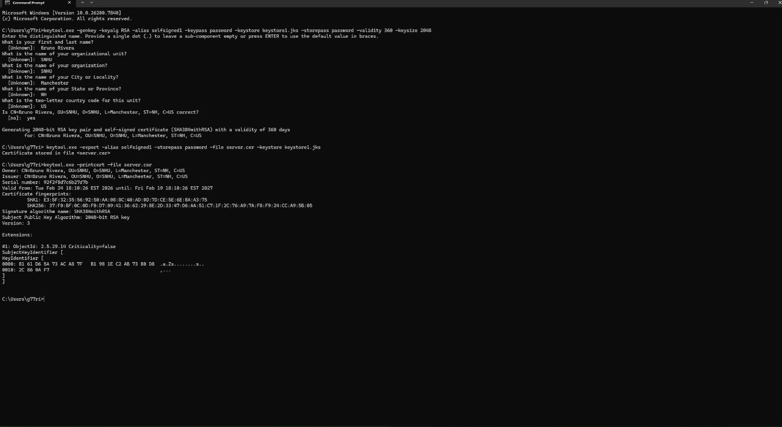

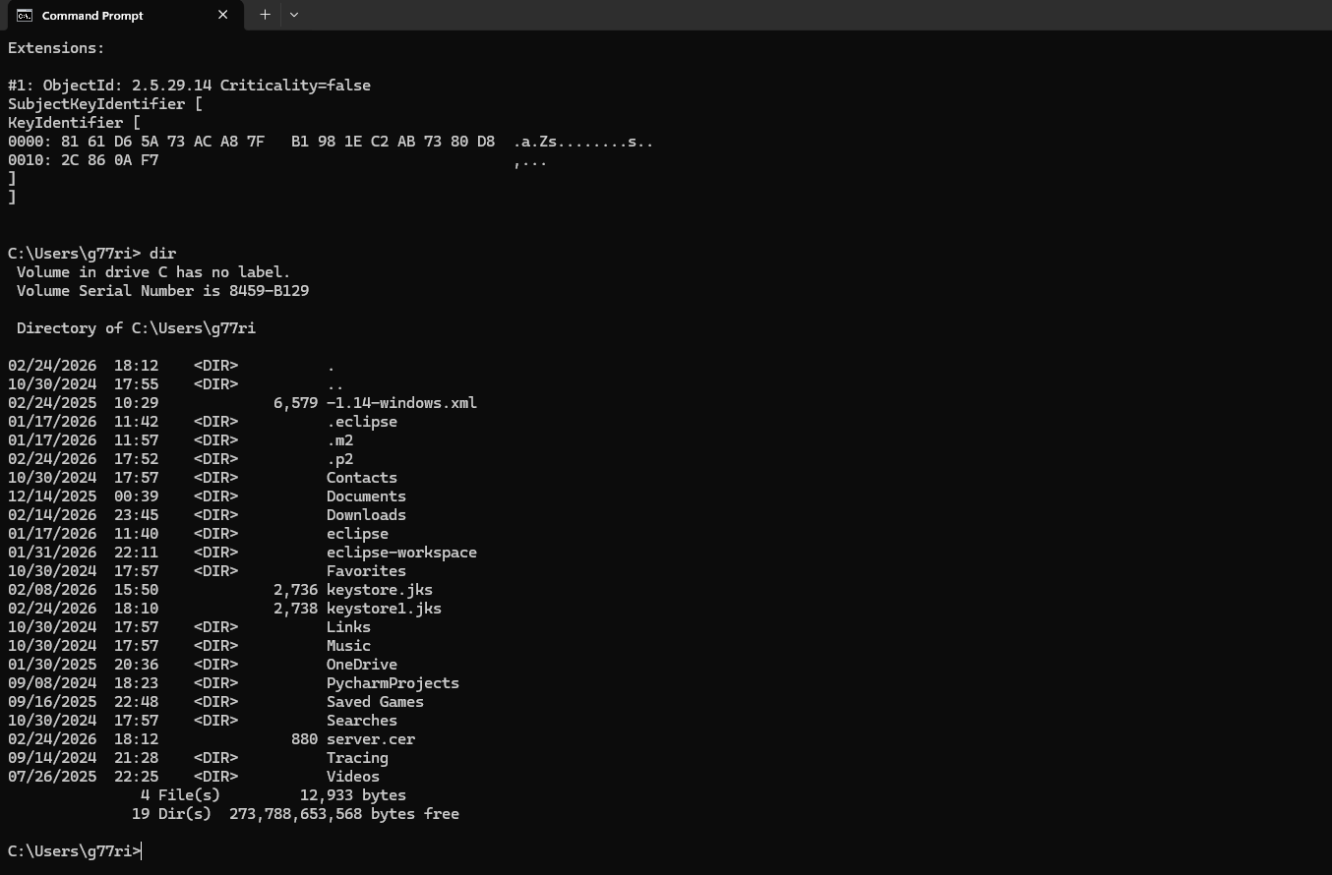

Deploy Cipher
Insert a screenshot below of the checksum verification.



Secure Communications
Insert a screenshot below the web browser that shows a secure webpage.



Secondary Testing
Insert screenshots below of the refactored code executed without errors and the dependency-check report.

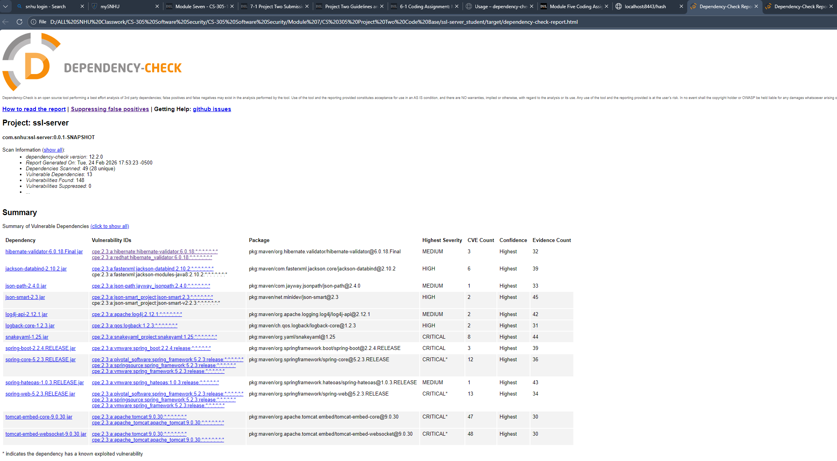

Summary

Some of the areas of security that was addressed during the whole refactoring process was our ability to use the application’s self-sign certificates. For me I used the command prompt of my PC. A key security improvement would be the use of HTTPS. And we also refactored the pom.xml file to show all vulnerabilities, highlighting them being fixed once we load up the dependency check.

As mentioned before, we use the command prompt of my PC to create the self-sign certificate. Similarly to what we did in Module 5, we made sure the certificate was created appropriately, securely and users will be able to conduct business with trust.

This is followed by making sure our hashing function is running correctly and this will give us a checksum. We looked through the application.properties and want to enable the HTTPS with SSL keystore. Replacing the question marks with the correct entries we did through the certification entries in the command prompts. It would look like this below:

server.port=8443
server.ssl.key-alias=selfsigned1
server.ssl.key-store-password=password
server.ssl.key-store=classpath:keystore1.jks
server.ssl.key-store-type=JKS

Then, we looked at the SslServerApplication.java and added a controller adding the @RestController. We also added a @RequestMapping that the program can run when the /hash is included.

Industry Standard Best Practices

Finally, in the last stage we made sure that all vulnerabilities were patched. Eventually, we will find resolutions to fix these errors. But in the meantime, we use the ability to suppress them and process with the project. This guarantees that our business can be prepared and it is as functioning as intended.

Overall, our organization needs to be protected from attacks from not only within our group. That is why it is best practice that we have only users that have access rather than being granted access to everyone. A controlled environment. Thank you.

References

Entrust. (2024). The History of Cryptography: Timeline & Overview | Entrust.com. https://www.entrust.com/resources/learn/history-of-cryptography

‌

